|  |  |  |  |  |  |  |  |  |
| --- | --- | --- | --- | --- | --- | --- | --- | --- |
|  | | | | | | | | |
|  | | AWS Lab 2 | | | | |  | |
|  |  | | | | | | |  |
|  | | | |  |  | | | |
|  | | | | Weizhen Chen |  | | | |
|  | | | | —CCNP—Jeffery Mason &Michael Hansen |  | | | |
|  | | |  | | |  | | |

# Lab 2: Build your VPC and Launch a Web Server

**Amazon Virtual Private Cloud (Amazon VPC)** enables you to launch Amazon Web Services (AWS) resources into a virtual network that you defined. This virtual network closely resembles a traditional network that you would operate in your own data center, with the benefits of using the scalable infrastructure of AWS. You can create a VPC that spans multiple Availability Zones.

**The purpose**

To use Amazon Virtual Private Cloud (VPC) to create your own VPC and add additional components to produce a customized network. You will also create a security group. You will then configure and customize an EC2 instance to run a web server and you will launch the EC2 instance to run in a subnet in the VPC.

**Task 1: Create an AMI for Auto Scaling**

1. In the search box, search and choose **VPC**
2. Create a VPC:

* In the top left of the screen, verify the **New VPC Experience** is toggled *on*. If it is not, toggle it on now.
* Choose the **VPC dashboard** link which is also towards the top left of the console.
* Next, choose **Create VPC**.

1. Configure the VPC:

* Choose **VPC and more**.
* Under **Name tag auto-generation**, keep *Auto-generate* selected, however change the value from project to lab.
* Keep the **IPv4 CIDR block** set to 10.0.0.0/16
* For **Number of Availability Zones**, choose **1**.
* For **Number of *public* subnets**, keep the **1** setting.
* For **Number of *private* subnets**, keep the **1** setting.
* Expand the **Customize subnets CIDR blocks** section
  + Change **Public subnet CIDR block in us-east-1a** to 10.0.0.0/24
  + Change **Private subnet CIDR block in us-east-1a** to 10.0.1.0/24
* Set **NAT gateways** to **In 1 AZ**.
* Set **VPC endpoints** to **None**.
* Keep both **DNS hostnames** and **DNS resolution** *enabled*.

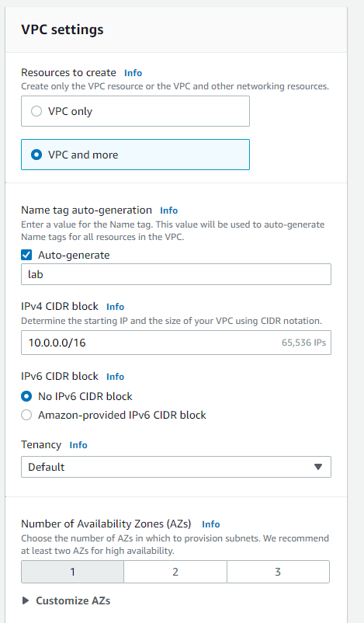

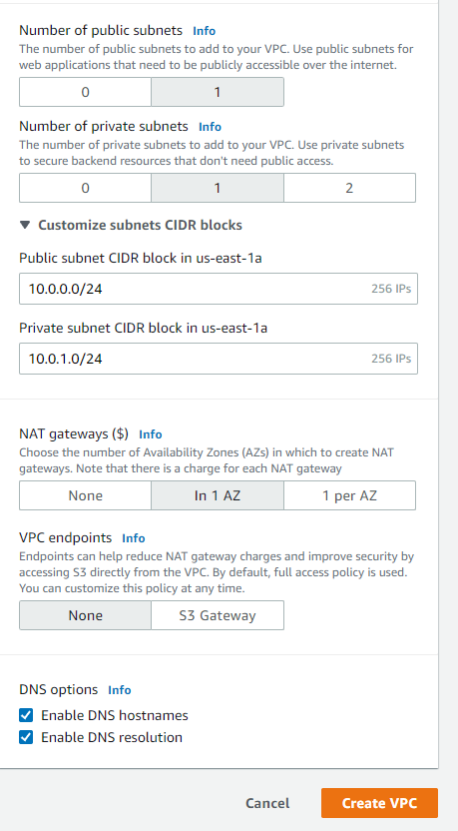

1. In the Preview panel, confirm the settings:

* **VPC:** lab-vpc
* **Subnets**:
  + us-east-1a
    - ***Public* subnet name:** lab-subnet-public1-us-east-1a
    - ***Private* subnet name:** lab-subnet-private1-us-east-1a
* **Route tables**
  + lab-rtb-public
  + lab-rtb-private1-us-east-1a
* **Network connections**
  + lab-igw
  + lab-nat-public1-us-east-1a

1. At the bottom, choose **Create VPC** and choose **View VPC**

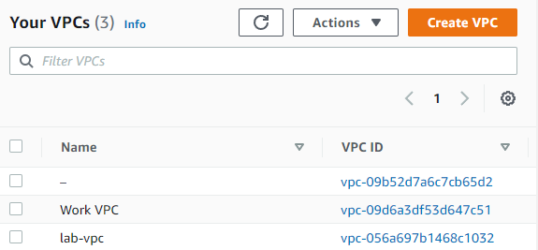

## Task 2: Create Additional Subnets

1. In the left navigation pane, choose **Subnets**.
2. Choose **Create subnet** then configure:

* **VPC ID:** **lab-vpc** (select from the menu).
* **Subnet name:** lab-subnet-public2
* **Availability Zone:** Select the *second* Availability Zone (for example, us-east-1b)
* **IPv4 CIDR block:** 10.0.2.0/24

1. Choose **Create subnet**

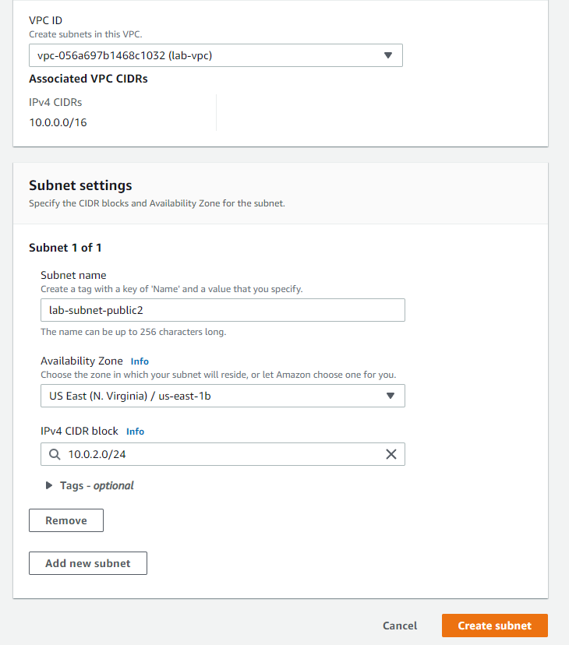

1. Choose **Create subnet** then configure:

* **VPC ID:** lab-vpc
* **Subnet name:** lab-subnet-private2
* **Availability Zone:** Select the *second* Availability Zone (for example, us-east-1b)
* **IPv4 CIDR block:** 10.0.3.0/24

1. Choose **Create subnet**

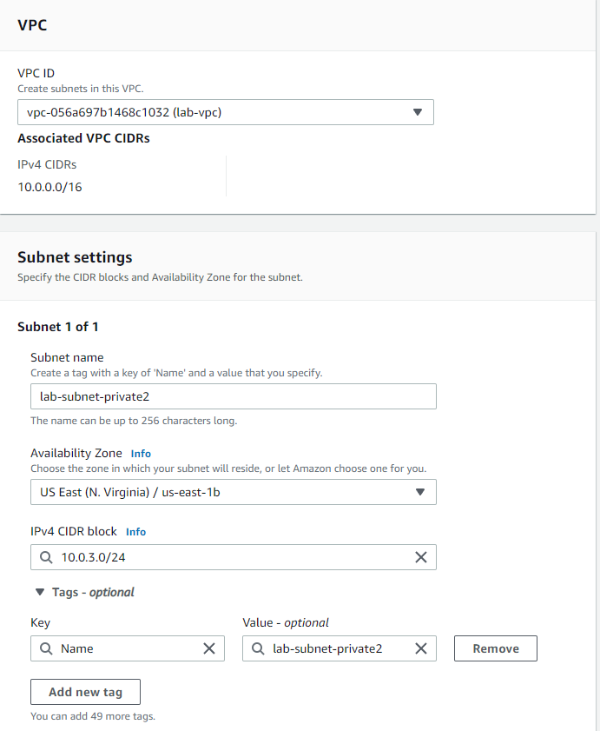

1. In the left navigation pane, choose **Route tables**.

* Select the **lab-rtb-private1-us-east-1a** route table

1. In the lower pane, choose the **Routes** tab.
2. Choose the **Subnet associations** tab.
3. Choose **Edit subnet associations**

* Leave **lab-subnet-private1-us-east-1a** selected, but also select **lab-subnet-private2**.

1. Choose **Save associations**.

* Select the **lab-rtb-public** route table (and deselect any other subnets).

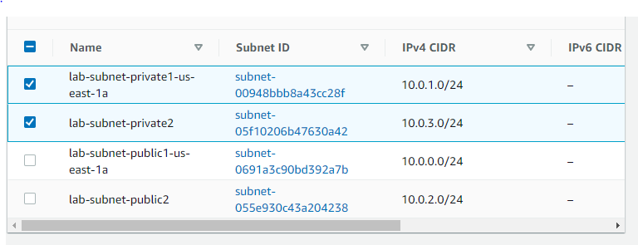

1. In the lower pane, choose the **Routes** tab. Choose the **Subnet associations** tab and Choose **Edit subnet associations**

* **lab-subnet-public1-us-east-1a** selected, but also select **lab-subnet-public2**.

1. Choose **Save associations**

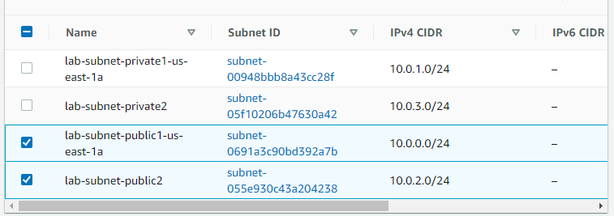

## Task 3: Create Additional Subnets

1. In the left navigation pane, choose **Security groups**.
2. Choose **Create security group** and then configure:

* **Security group name:** Web Security Group
* **Description:** Enable HTTP access
* **VPC:** choose the X to remove the currently selected VPC, then from the drop down list choose **lab-vpc**

1. In the **Inbound rules** pane, choose **Add rule and configure:**

* **Type:** *HTTP*
* **Source:** *Anywhere-IPv4*
* **Description:** Permit web requests

1. choose **Create security group**

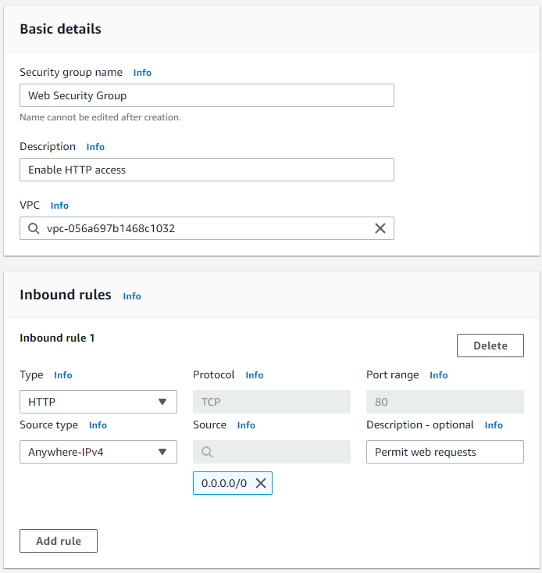

## Task 4: Launch a Web Server Instance

1. In the search box to the right of **Services**, search for and choose **EC2** to open the EC2 console.
2. Choose **Launch instance**.
3. Name the instance:

* Give it the name Web Server 1

1. Choose an AMI from which to create the instance:

* In the list of available *Quick Start* AMIs, keep the default **Amazon Linux** AMI selected.
* Also keep the default **Amazon Linux 2 AMI (HVM)** selected.

1. Choose an Instance type:

* In the *Instance type* panel, keep the default **t2.micro** selected.

1. Select the key pair to associate with the instance:

* From the **Key pair name** menu, select **vockey**.

1. Configure the Network settings:

Next to Network settings, choose **Edit**, then configure:

* + **Network:** *lab-vpc*
  + **Subnet:** *lab-subnet-public2* (*not* Private!)
  + **Auto-assign public IP:** *Enable*

Next, you will configure the instance to use the *Web Security Group* that you created earlier.

* + Under Firewall (security groups), choose **Select an existing security group**.
  + For **Common security groups**, select **Web Security Group**.

1. In the *Configure storage* section, keep the default settings.
2. Configure a script to run on the instance when it launches:

* Expand the **Advanced details** panel.
* Scroll to the bottom of the page and then copy and paste the code shown below into the **User data** box

1. At the bottom of the **Summary** panel on the right side of the screen choose **Launch instance**
2. Choose **View all instances**
3. Select **Web Server 1** and copy the **Public IPv4 DNS** value shown in the **Details** tab at the bottom of the page
4. Open a new web browser tab, paste the **Public DNS** value and press Enter

